Ensuring the success and safety
of young kids who make mistakes

Testimony to the House Committee on Juvenile Justice and Family Issues
Youth as young as 10 can be arrested, enter the Texas juvenile justice system, be detained in a local detention center, and even be placed in secure lock-up for months on end. Last year, Texas youth age 10 to 13 spent a total of 144,788 days locked up in detention and secure placements, stunting their development and facing the stigma of the juvenile justice system. Fortunately, there are more appropriate, effective child-serving systems that can keep youth safe while helping them overcome their past traumas and keep on a path to success. Texas should take steps to keep all youth age 10 to 13 out of the juvenile justice system.

From the day a Texas child turns 10, to the day before her 17th birthday, she can be arrested or referred to the Texas juvenile justice system for delinquent conduct or conduct in need of supervision (CINS).

A significant number of youth age 13 and younger are referred to juvenile probation. Last year 8,866 youth age 10 to 13 accounted for 21 percent of the referrals and arrests to juvenile probation. They are less like to be adjudicated delinquent than older youth. These youngest kids account for only 12 percent of the adjudications of 10-16 year olds.

Unique Referrals to Texas’ Juvenile Justice System by Age (CY 2015)
10 | 11 | 12 | 13 | 14 | 15 | 16 | Total
392 | 999 | 2,496 | 4,979 | 8,068 | 10,974 | 13,456 | 41,364

Most of Them Committed Misdemeanors and Non-violent Offenses
Like all youth in the juvenile justice system, the vast majority of the offenses landing youth age 10-13 in the juvenile justice system are misdemeanors, CINS (such as XXX), status offenses (such as running away), and violation of court orders. A full 86 percent were for non-violent offenses. In 2015, 19 percent of the dispositions of 10 to 13-year-olds were disposed to probation – including community supervision and placements. Meanwhile, 38 percent of them were under informal supervisions through deferred prosecution.

In fact, nearly half (42 percent) of youth 13 years and younger were referred to juvenile probation for misbehavior on school campus or at a school-related function, including 47 percent of 10-year-olds and 46 percent of 12-year-olds.

Many of these Youth have Significant Needs, Trauma and/or CPS Histories
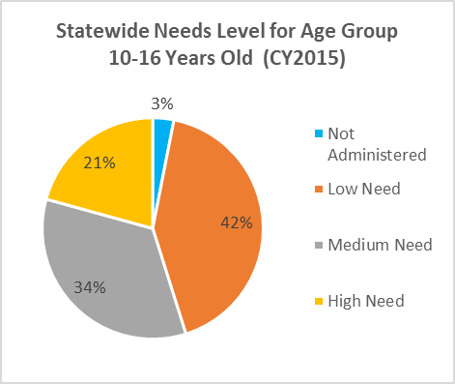
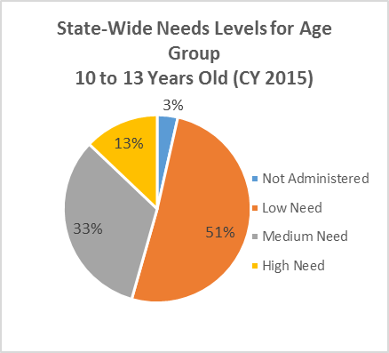
Needs assessments administered on youth show that a third of the youngest youth entering the system are identified as “medium need” and another 13 percent as “high need.” While there are slightly more older youth in the justice system identified as “high need,” there are still a number of youth in need of services to prevent additional behavioral concerns and to address past trauma.
The youngest youth in the juvenile justice system, have similar trauma scores as the older youth in the system. The 10, 11 and 12-year-olds entering the juvenile justice system have experienced nearly the same amount of trauma that the 15 and 16-year-olds entering the system have experienced. While the data cannot tell us at what age the youth have experienced trauma, we do know that many of the youngest kids have experienced traumatic events in the first 10, 11 or 12 year of their life and are in need of supports and services to overcome their past traumas.

Research in jurisdictions outside of Texas have found that as many as two-thirds of youth involved in the juvenile justice system have previous or current involvement in the child welfare system, usually through investigated or substantiated abuse and neglect cases. The research also suggests that youth with previous child welfare involvement enter the juvenile justice at a much younger age and are detained more frequently and spend more time in detention than youth who have not had involvement with the child welfare system. Texas does not have accurate data regarding juvenile justice-involved youth who have been involved in child welfare, however it is quite likely that a large portion of the youngest children in the Texas juvenile justice system have current or previous cases with Texas CPS.

Including Them in the Juvenile Justice System in Counterproductive
Youth age 10 to 13 would be better served in settings outside of the juvenile justice system and outside of lock-ups. Including them in the juvenile justice system is counterproductive in multiple ways.

Harmful Stigma
Putting these youth into the stigmatizing juvenile justice system at an early age often labels them as “delinquents” to teachers, peers, neighbors -- and themselves. That stigma undermines their ability to get on the right path in life.

Services Designed for Older Youth
Because the population of the juvenile justice system is predominately youth in their mid- to late-teens, programming and services available to juvenile probation and in lock-ups are geared toward that population. Other systems can better serve these youth, without the potential harm caused by going through programming with older delinquent youth.

Processing youth through the juvenile justice does not improve public safety and can be harmful
Research has shown that formally processing youth through the juvenile justice can “backfire” and have harmful effects, including increasing a youth’s subsequent delinquency, creating a cycle of delinquency and justice involvement.

Confinement is Significant – and Harmful
In 2015, the youngest youth in the juvenile justice system – 10, 11, 12 and 13 year olds – were detained 5,813 times – held in secure confinement without ever having been adjudicated. That’s is 73,296 days in 2015 that some of the state’s most vulnerable youth, and the youngest in the juvenile justice system, spent locked up, away from their families and away from school as they got behind in class – all before or instead of a “finding of true” that the youth had committed a delinquent act.

Detention of the Youngest Youth in the Juvenile Justice System*
Age of youth | # of Detentions | Average Length of Detention (days)
10 | 165 | 6.85
11 | 559 | 11.3
12 | 1521 | 11.93
13 | 3568 | 13.37
*number of detentions, does not necessarily reflect the number of youth detained. Some youth may have been detained on more than one occasion over the course of a year.

While the youngest youth who are detained spend slightly less time in detention than the older youth, the youngest youth receiving post-adjudication probation placements spend much more time in both secure and non-secure placements than their older counterparts.
Youth in Secure Placements in CY2015
Age of youth | # of Secure Placements | Average Length of Placement (days)
10 | < 5 | 206
11 | 23 | 227
12 | 96 | 200
13 | 260 | 180
14 | 696 | 164
15 | 1150 | 151
16 | 1287 | 146

Youth in Non-Secure Placements
Age of youth | # of non-Secure Placements | Average Length of Placement (days)
10 | 13 | 280
11 | 70 | 146
12 | 194 | 152
13 | 452 | 110
14 | 919 | 106
15 | 1235 | 107
16 | 1296 | 108

Placing youth in secure confinement -- detention or placement -- at a young age is counterproductive to their development. It can exacerbate social, academic, and emotional difficulties while limiting opportunities for positive experiences and development. Research has found that confinement can cause short-term declines in psychosocial maturity for youth, including declines in tempering aggressive and impulsive behavior, personal responsibility, and perspective.

Texas has Numerous, More Appropriate Child-Serving Systems to Support Youth with Behavioral Health Concerns
The youngest youth entering the justice system and in need of rehabilitative services are more appropriately served in systems prepared to address their needs. There are several options:

Local Mental Health Authorities can, and often already do, provide services such as counseling, substance use treatment, psychiatric treatment, and other in-home mental health community-based services to these youth.

Child Welfare System/CPS can provide youth in-home or community-based counseling, family supports and family counseling, and parent supports. And when in-patient treatment is absolutely necessary, and other options have been exhausted, CPS can place youth in non-secure residential treatment centers.
Prevention and Early Intervention programs such as Services to At Risk Youth (STAR) and Community Youth Development (CYD) are already serving youth similar to this population. They provide services such as mentoring, counseling, family counseling, family-based crisis intervention, and other delinquency prevention and early intervention programming.
Our schools, instead of referring these young kids to the juvenile justice system, should implement evidence-based strategies that reduce behavioral challenges in the classroom and help students with mental health concerns be successful in school. Effective school-based practices include:
- social emotional learning,
- positive behavioral interventions and supports,
- safe and supportive school climates, and
- trauma-informed practices.
The state should provide supports and guidance to schools to identify and implement appropriate programs in their schools. For youth with high needs, the school may also refer youth and their families to appropriate child-serving systems such as those listed above.

How do other states treat young children with behavioral challenges?
Currently, 18 states have a minimum age of juvenile court jurisdiction set in statute. When set in statute, the minimum age ranges from 6 in North Carolina to 11 in Nebraska. The remaining 32 states have no minimum age in statute, however through case law and best practices many effectively have minimum ages of juvenile justice involvement. For example, in California a child must “appreciate the wrongfulness” of his/her conduct, and in Ohio a child must “understand the nature and objective of the proceedings against him.” In both states, the courts generally presume that standard applies to youth 14 and older. In Florida, no statute or case law prevails; instead system practitioners just say that 12 is “universally accepted” as the lower age of jurisdiction.

Recommendation: The Texas Legislature should raise the minimum age at which youth can enter the Texas juvenile justice system and ensure other child-serving systems have the resources they need to provide appropriate supports to these youth.

Janet K. Wiig and John A. Tuell, with Jessica K. Heldman. Guidebook for Juvenile Justice & Child Welfare System Coordination and Integration. 2010 Update.
Petrosino, Anthony. “Formal System Processing of Juveniles: Effects on Delinquency”, January 29, 2010. Available here: www.campbellcollaboration.org/lib/download/760/
“Stages of adolescent development,” Adapted from the American Academy of Child and Adolescent’s Fact for Families 2007.
Nationl Juvenile Justice Network, “Arrested Development: Confinement Can Negatively Affect Youth Maturation”. (Dec 2013)

